Facemask Detector

***Wireframe Documentation***

**Home page**

1. This home page that should be available for the user.

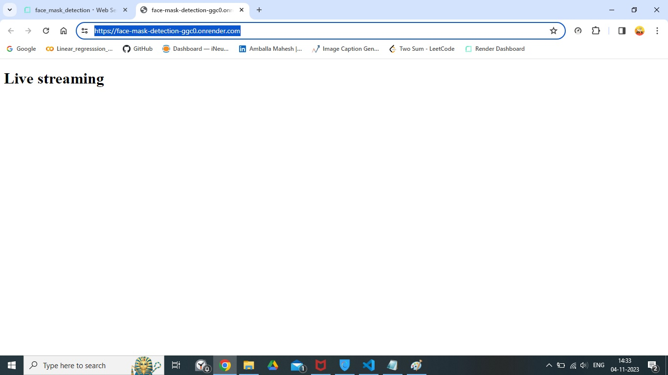

1. The user should get the output as below mentioned..

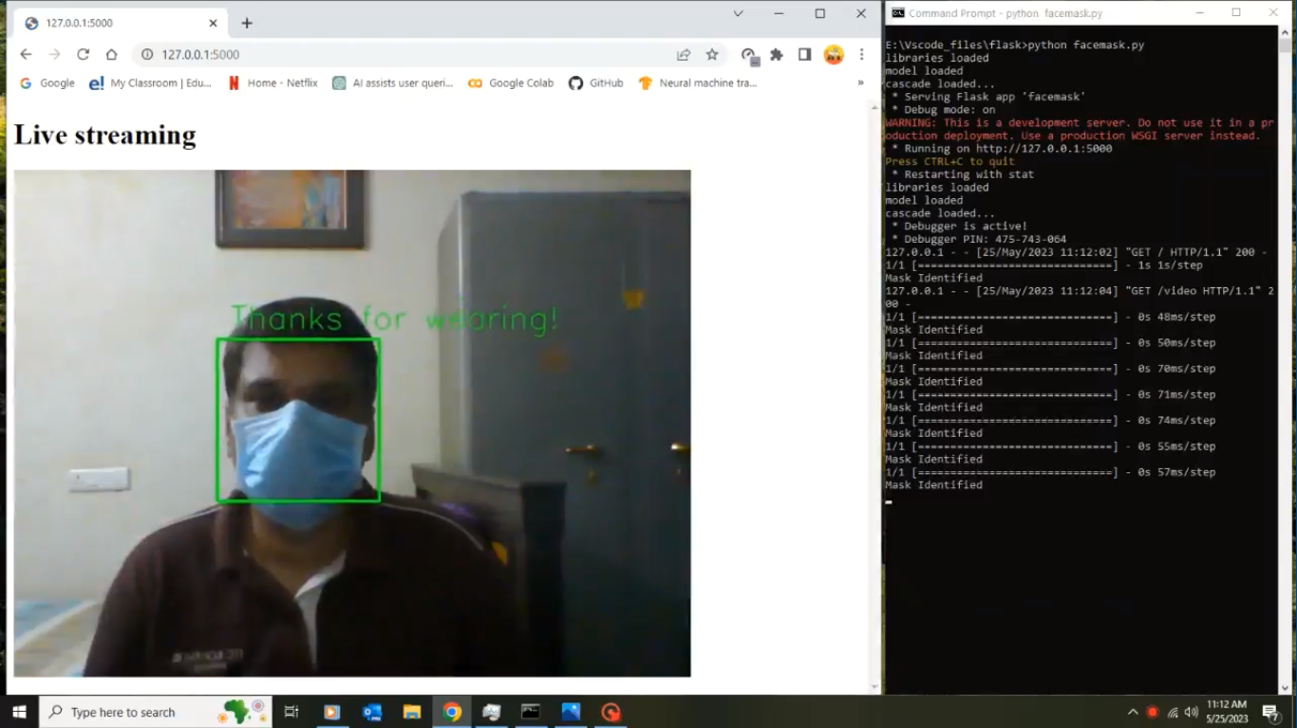

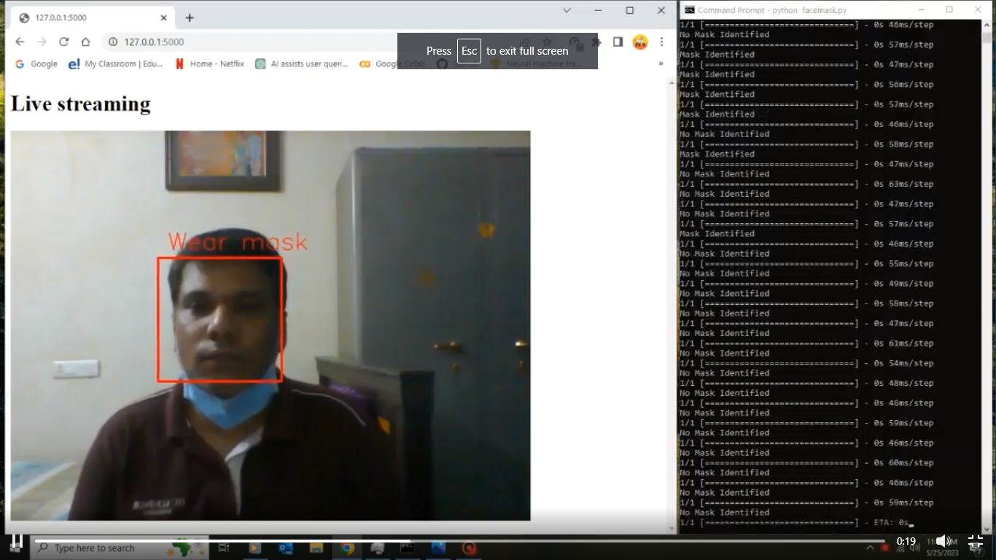

1. Check the logging file whether the logging is active or not.

